Confidence-Calibrated Camera–LiDAR Fusion under Sensor Shift: Synchronized-Pair Association, Anomaly Detection, and Proposal-Tracklet Continuity
William Moore¹, Brian Ye², Mia Anderson³, Sabrina Hou⁴

¹Department of Computer Science, Emory University, Atlanta, GA, USA,
²Department of Computer Science, Indiana University Bloomington, Bloomington, IN, USA
³Department of Computer Science, The University of Texas at Austin, Austin, TX, USA
⁴Department of Computer Science, University of Colorado Boulder, Boulder, CO, USA

Email: ^{1*}w.moore_emory@outlook.com

Abstract
Camera–LiDAR fusion can fail when sensor quality, synchronization, or extrinsic calibration departs from the conditions used to construct the fusion rule. This study evaluates whether confidence calibration makes those failures more visible and reduces overconfident association decisions. Experiments used the DAVE inland-waterway sequence, comprising 128 synchronized 1280 × 720 images, 128 LiDAR point clouds containing 5,719,139 XYZ points, and 781 scored two-dimensional privacy proposals. A chronological 64/32/32-frame train/calibration/test split prevented future frames from entering model fitting. Pair association distinguished synchronized camera–LiDAR frames from frames offset by 1, 2, 4, 8, or 16 s. Image-only, LiDAR-only, early summary-fusion, late evidence-rule, learned-fusion, and confidence-gated models were compared. Held-out discrimination was near chance: learned fusion obtained AUROC 0.4971 and confidence-gated fusion obtained 0.4865. Relative probability quality nevertheless improved on this block. The Platt-calibrated, confidence-gated pipeline reduced Brier score from 0.1768 to 0.1571 and expected calibration error from 0.1743 to 0.0968 relative to the uncalibrated learned model; paired frame-block bootstrap differences were −0.0197 (95% interval −0.0218 to −0.0177) and −0.0730 (−0.0827 to −0.0465), respectively. The fixed severe blur, camera-noise, LiDAR-dropout, and modality-loss conditions were perfectly separated, whereas temporal offsets and fixed extrinsic perturbations remained difficult. Because DAVE provides neither track identities nor manually verified object boxes, temporal experiments report continuity, forward–reverse agreement, edge retention, and spurious-link proxies rather than MOTA, IDF1, or HOTA. JPDA-style affinity produced the highest clean link rate, whereas confidence gating gave the best edge-retention and spurious-link proxies under bounding-box jitter. Calibration can therefore improve the meaning of confidence without creating discriminative evidence absent from the sequence..

Keywords: Camera–Lidar Fusion; Confidence Calibration; Sensor Shift; Synchronization; Anomaly Detection; Sensor-Pair Association; Tracklet Continuity; Autonomous Inland Navigation.

Abstrak
Fusi kamera-LiDAR dapat mengalami kegagalan ketika kualitas sensor, sinkronisasi, atau kalibrasi ekstrinsik menyimpang dari kondisi yang digunakan untuk menyusun aturan fusi. Studi ini mengevaluasi apakah kalibrasi tingkat kepercayaan (confidence calibration) membuat kegagalan tersebut lebih terlihat dan mengurangi keputusan asosiasi yang terlalu percaya diri (overconfident). Eksperimen menggunakan rangkaian data perairan darat DAVE, yang mencakup 128 citra tersinkronisasi berukuran 1280 × 720, 128 point cloud LiDAR yang memuat 5.719.139 titik XYZ, serta 781 usulan privasi dua dimensi yang telah diberi skor. Pembagian data secara kronologis (64/32/32 frame untuk pelatihan/kalibrasi/pengujian) mencegah masuknya frame masa depan ke dalam proses penyesuaian model. Asosiasi pasangan membedakan antara frame kamera-LiDAR yang tersinkronisasi dengan frame yang memiliki selisih waktu (offset) 1, 2, 4, 8, atau 16 detik. Model-model yang dibandingkan meliputi model berbasis citra saja, LiDAR saja, fusi ringkasan awal (early summary-fusion), aturan bukti akhir (late evidence-rule), fusi hasil pembelajaran (learned-fusion), dan fusi dengan gerbang kepercayaan (confidence-gated). Kemampuan diskriminasi pada data uji berada di tingkat peluang acak (chance level): fusi hasil pembelajaran memperoleh nilai AUROC 0,4971 dan fusi dengan gerbang kepercayaan memperoleh 0,4865. Meskipun demikian, kualitas probabilitas relatif meningkat pada blok data ini. Alur kerja (pipeline) yang menggunakan kalibrasi Platt dan gerbang kepercayaan berhasil menurunkan skor Brier dari 0,1768 menjadi 0,1571 serta expected calibration error dari 0,1743 menjadi 0,0968 dibandingkan dengan model hasil pembelajaran tanpa kalibrasi; perbedaan bootstrap berpasangan pada tingkat blok-frame masing-masing adalah −0,0197 (interval 95%: −0,0218 hingga −0,0177) dan −0,0730 (interval 95%: −0,0827 hingga −0,0465). Kondisi berupa kabur (blur) parah yang tetap, derau kamera, dropout LiDAR, dan hilangnya modalitas dapat dipisahkan dengan sempurna, sedangkan offset temporal dan gangguan ekstrinsik tetap sulit ditangani. Karena DAVE tidak menyediakan identitas lintasan (track identities) maupun kotak objek yang diverifikasi secara manual, eksperimen temporal melaporkan metrik kontinuitas, kesesuaian maju-mundur, retensi tepi, dan proksi tautan semu (spurious-link proxies), alih-alih menggunakan metrik MOTA, IDF1, atau HOTA. Metode affinity ala JPDA menghasilkan tingkat clean link tertinggi, sedangkan confidence gating memberikan hasil terbaik dalam hal retensi tepi (edge-retention) dan indikator spurious-link di bawah kondisi jitter kotak pembatas (bounding-box). Dengan demikian, kalibrasi dapat meningkatkan makna nilai kepercayaan (confidence) tanpa menciptakan bukti diskriminatif yang sebenarnya tidak ada dalam urutan data tersebut.

Kata Kunci: Fusi Kamera-Lidar; Kalibrasi Kepercayaan; Pergeseran Sensor; Sinkronisasi; Deteksi Anomali; Asosiasi Pasangan Sensor; Kontinuitas Tracklet; Navigasi Perairan Pedalaman Otonom.

- INTRODUCTION
Cameras provide dense appearance, while LiDAR provides metric range and geometry. Fusion has progressed from multi-view and proposal aggregation [1], [2], through point-, voxel-, and candidate-level integration [3], [4], [5], to transformer and bird's-eye-view representations [6], [7]. These gains assume synchronization, calibration, and healthy sensors. Blur, point loss, modality absence, and spatial or temporal misalignment violate those assumptions; corruption and adverse-weather studies confirm that complementary sensors do not guarantee robustness [8], [9]. Targetless mutual-information calibration [10] and learned self-calibration such as LCCNet [11] likewise address the projection errors that undermine fusion.
Recent work on uncertainty-aware late fusion explicitly treats confidence calibration and fusion-rule learning as separate design problems [12], while object-level LiDAR–camera tracking has combined JPDA and EKF to preserve ambiguity through the association stage [13]. Attention-enhanced autonomous-driving detectors [14] and domain adaptation with approximately shared features [15] further suggest that richer local evidence and transfer structure can matter as much as the fusion operator. These studies motivate a decomposed evaluation in which cross-modal evidence, discriminative ranking, probability calibration, and temporal association are measured separately rather than summarized by a single fusion score.
Confidence is distinct from the binary decision. Models may be poorly calibrated even when accurate [16], and calibration may deteriorate under shift [17]. A fusion system should therefore distinguish ranking quality from whether scores reflect observed correctness. A calibrated but weak score can support abstention; an overconfident score can silently propagate errors.
That separation is also consistent with uncertainty-aware decision pipelines outside perception. Probability calibration with uncertainty-driven rejection has been studied for credit-risk tiering [18], distribution-free uncertainty and SHAP-based model-risk workflows [19], calibrated capacity forecasting [20], and conformal demand envelopes for risk-bounded GPU admission [21]. Across these settings, uncertainty is operationally useful only when it is tied to an explicit action—accept, defer, abstain, or escalate. The present study therefore treats the reliability gate as a decision layer and does not interpret a lower Brier score as evidence of better synchronized-pair ranking.
ModDrop [22] and EmbraceNet [23] motivate quality-aware handling of absent inputs. They do not remove the need to test whether a gate responds to deterioration and complete loss, nor can lowered confidence repair missing discriminative evidence.
Model capacity does not eliminate this distinction. Lightweight medical foundation models with parameter-efficient transfer [24], uncertainty-aware medical vision–language classifiers [25], and edge-oriented quality proxies distilled from richer metrics [26] illustrate how compact representations can support calibration and deployment without guaranteeing cross-domain discrimination. We accordingly keep the DAVE representation deliberately lightweight, then test whether its confidence responds to blur, point loss, and modality absence.
Temporal association combines motion prediction [27], one-to-one assignment [28], and probabilistic treatment of ambiguous measurements [29], [30]. SORT and AB3DMOT provide lightweight precedents [31], [32], while EagerMOT and DeepFusionMOT combine camera and LiDAR cues [33], [34]. Verified identities remain essential: HOTA compares detection, localization, and association against annotated trajectories [35], so using it without labels would confuse smoothness with accuracy.
This study uses DAVE, a camera-LiDAR sequence recorded on the River Trave [36] within an autonomous inland-waterway program [37]. Related work documents its ROS 2 calibration and projection pipeline [38] and bridge perception [39]. DAVE supports lightweight shift experiments, but its JSON records are scored privacy-blur proposals, not human identities or 3D boxes.
Route-to-route deployment would additionally create a domain-shift problem. Cross-cloud workload forecasting has shown that transfer can become negative when source and target distributions separate [40], while few-shot cold-start forecasting emphasizes the value of target-specific support windows [41]. Regime-aware forecasting under changing weather and seasonality provides a parallel example of nonstationary evidence [42], and multi-horizon forecasting with operational risk curves illustrates the need to monitor errors at more than one decision horizon [43]. These works motivate chronological evaluation and explicit shift analysis here, although DAVE contains only one route and therefore cannot support a genuine cross-route transfer experiment.
The experiments ask whether cross-modal features identify synchronized pairs, whether held-out calibration improves probability quality, which failures are visible to unimodal, residual, and one-class detectors, and how association rules respond to known proposal perturbations. Isolation Forest is the nonlinear anomaly baseline [44]; deep one-class classification represents a higher-capacity direction [45]. A chronological protocol, paired frame-block bootstrap, nine sensor conditions, and five temporal rules form the stress test. The key finding is qualified: the Platt-calibrated, confidence-gated pipeline reduces Brier score and ECE relative to the uncalibrated learned model on this block and creates fail-closed behavior, but it does not improve synchronized-pair discrimination.
The scope is therefore intentionally narrower than end-to-end 3D detection. The study asks what the released sequence can actually support: frame-pair association, fixed corruption detection, and proposal-link continuity. It avoids importing detector average precision or identity metrics that the archive cannot validate, and it treats operational evidence quality as a separate question from object-level accuracy..

- METHODS
Dataset And Chronological Protocol
DAVE v1 was published on May 27, 2024 [36]. The scientific payload contains 128 complete image-JSON-PCD triplets with timestamp stems from 2024_04_18_13_54_18 through 2024_04_18_13_56_25. The stems form 128 observations at nominal one-second intervals across a 127-s span. Every image has 1280 x 720 pixels. The binary PCD headers and payloads contain little-endian float32 x, y, and z coordinates. Although the accompanying README describes reflectivity, no reflectivity field occurs in the PCD schema, so intensity-based fusion was not modeled.
The point clouds contain 31,740-58,731 points per frame, with median 44,072.5 and total 5,719,139. The JSON files supply 781 scored privacy proposals in eight detector categories: person 281, car 178, boat 150, train 67, bus 42, truck 39, airplane 19, and bicycle 5. These category names and scores were retained as proposal attributes but were not treated as verified semantic labels. Two frames contain no proposals. Calibration metadata supplies a 3 x 4 projection matrix and a 4 x 4 LiDAR-to-camera extrinsic matrix.

Table 1 Dave Sequence And Schema Audit
Item | Observed value | Interpretation
Synchronized triplets | 128 | frames
Timestamp span | 127 | s; 128 frames at nominal 1 Hz
Image resolution | 1280 x 720 | pixels
Total LiDAR points | 5719139 | XYZ points
LiDAR points/frame | 31,740-58,731 | median 44,072.5
Supplied 2D proposals | 781 | scored privacy-blur records
Proposal categories | 8 | person:281, car:178, boat:150, train:67, bus:42, truck:39, airplane:19, bicycle:5
PCD fields | x, y, z | float32; no reflectivity field
Ground-truth identities | 0 | not provided

Frames were divided chronologically into training, calibration, and test blocks. Model fitting used frames 0–63, and post-hoc calibration and confidence-threshold selection used frames 64–95. Synchronized-pair, sensor-shift, and anomaly results used frames 96–127. Proposal-tracklet continuity traversed all 128 frames as a descriptive sequence analysis; its controlled proposal perturbations were applied only after constructing each method's clean link graph. Transformations were generated after partitioning. Chronological separation avoids the direct leakage produced by random sampling of adjacent frames, although all partitions remain correlated segments of one run.
The identical filename stem defined the operationally synchronized pair. The archive does not provide a separate hardware timestamp stream or per-point acquisition times, so the experiment tests recovery of the released pairing rather than sub-frame physical simultaneity. This distinction matters at 1 Hz: a one-frame mismatch is a full second, while rolling-shutter, scan-time, and millisecond synchronization errors cannot be resolved from the released fields. The pairing labels are therefore exact for the controlled offset task but do not certify absolute sensor timing.

Table 2 Chronological Data Split
Block | Frames | Start | End | Proposals | LiDAR points
Train | 64 | 13:54:18 | 13:55:21 | 398 | 2,844,023
Calibration | 32 | 13:55:22 | 13:55:53 | 160 | 1,718,828
Test | 32 | 13:55:54 | 13:56:25 | 223 | 1,156,288

Camera, Lidar, And Cross-Modal Representation
Camera summaries were luminance mean and deviation, 64-bin entropy, normalized Sobel sharpness, edge density, saturation, and missingness. Sobel magnitude was divided by its 95th percentile; values at least 0.42 defined edges, pooled on 16 x 16 pixel cells. LiDAR points were transformed with the supplied extrinsic, filtered at camera depth above 0.10 m, projected, and clipped to the image. Summaries covered point retention, front and in-frame ratios, projected count, depth median and interquartile range, occupancy, and missingness. No distortion correction or surveyed recalibration was added.
The camera branch intentionally uses summary features rather than a new detector. Attention-enhanced image-detection work [14] indicates that local learned features are a plausible extension, but introducing a separately trained detector would entangle sensor synchronization with detector generalization. Likewise, the late-fusion study in [12] motivates retaining explicit modality confidence and fusion evidence rather than allowing one opaque model to absorb both.
Cross-modal evidence included LiDAR depth-edge proximity to image edges, grid Spearman and cosine relationships, camera gradients sampled at projected points, and LiDAR support within privacy proposals. Support measured boxes with at least one or five points, density, score-weighted support, and median depth. A supported proposal used the 20th depth percentile when at least three points were present. Causal temporal features compared camera-edge change with LiDAR occupancy and depth-edge change; partition boundaries used zero change.
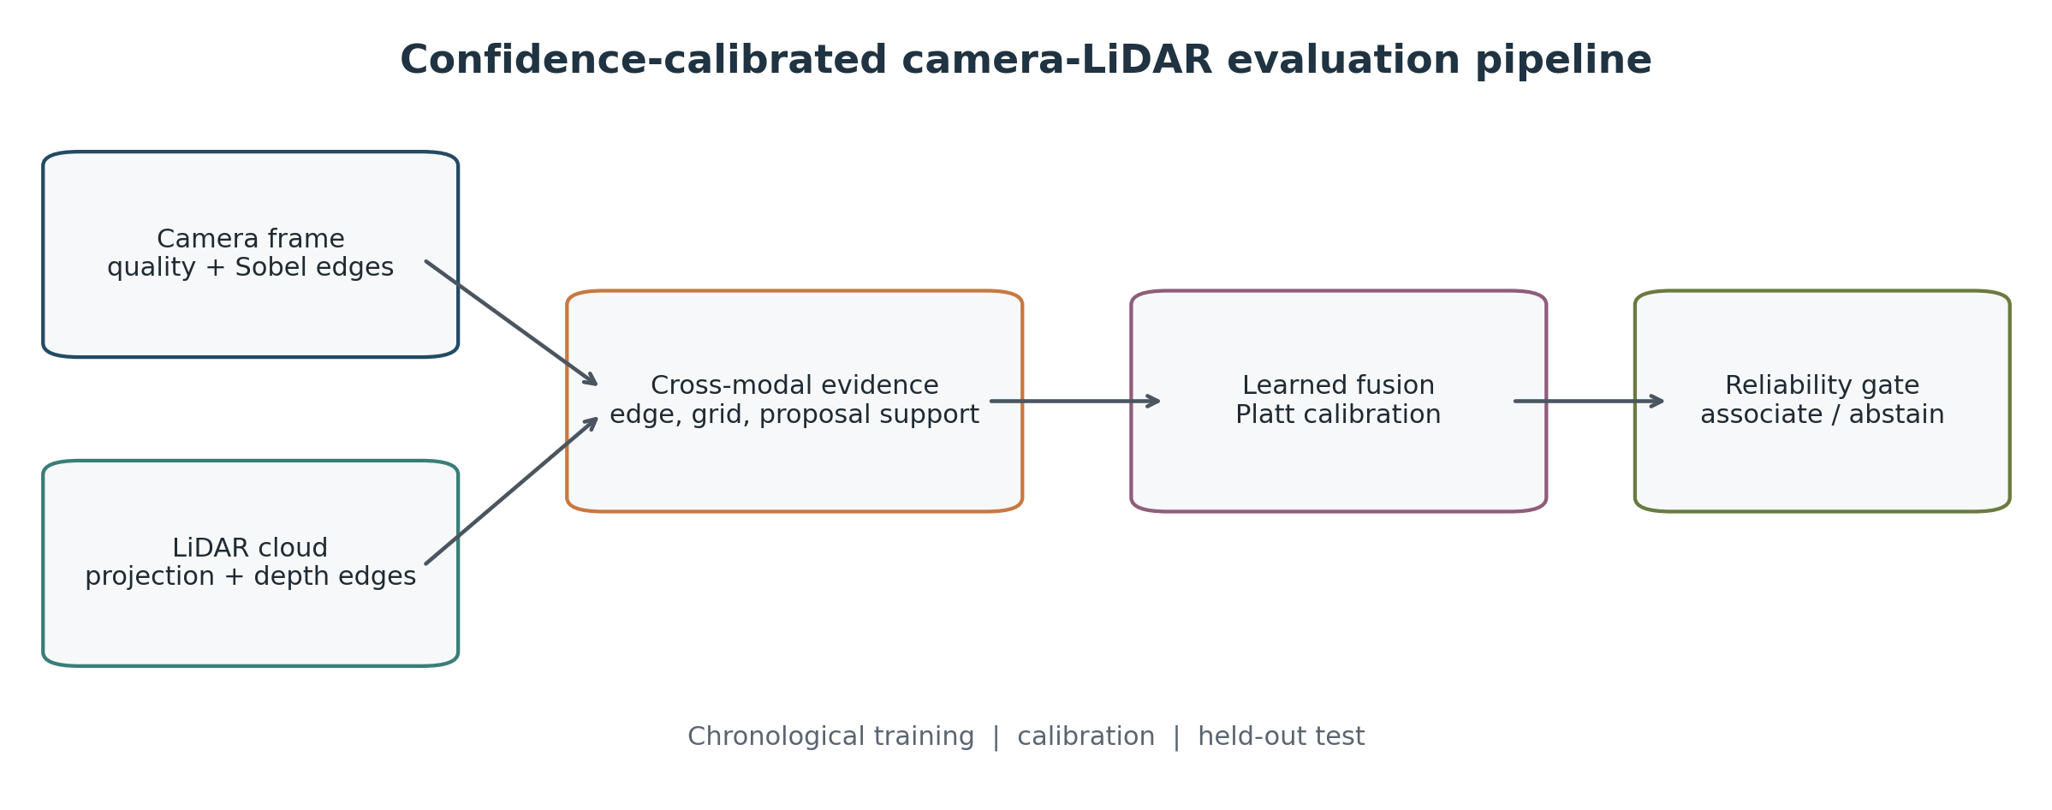
Figure 1 Evaluation Pipeline. Camera Quality And Edge Evidence Are Combined With Projected Lidar Depth Structure, Followed By Learned Fusion, Post-Hoc Calibration, And A Reliability Gate.
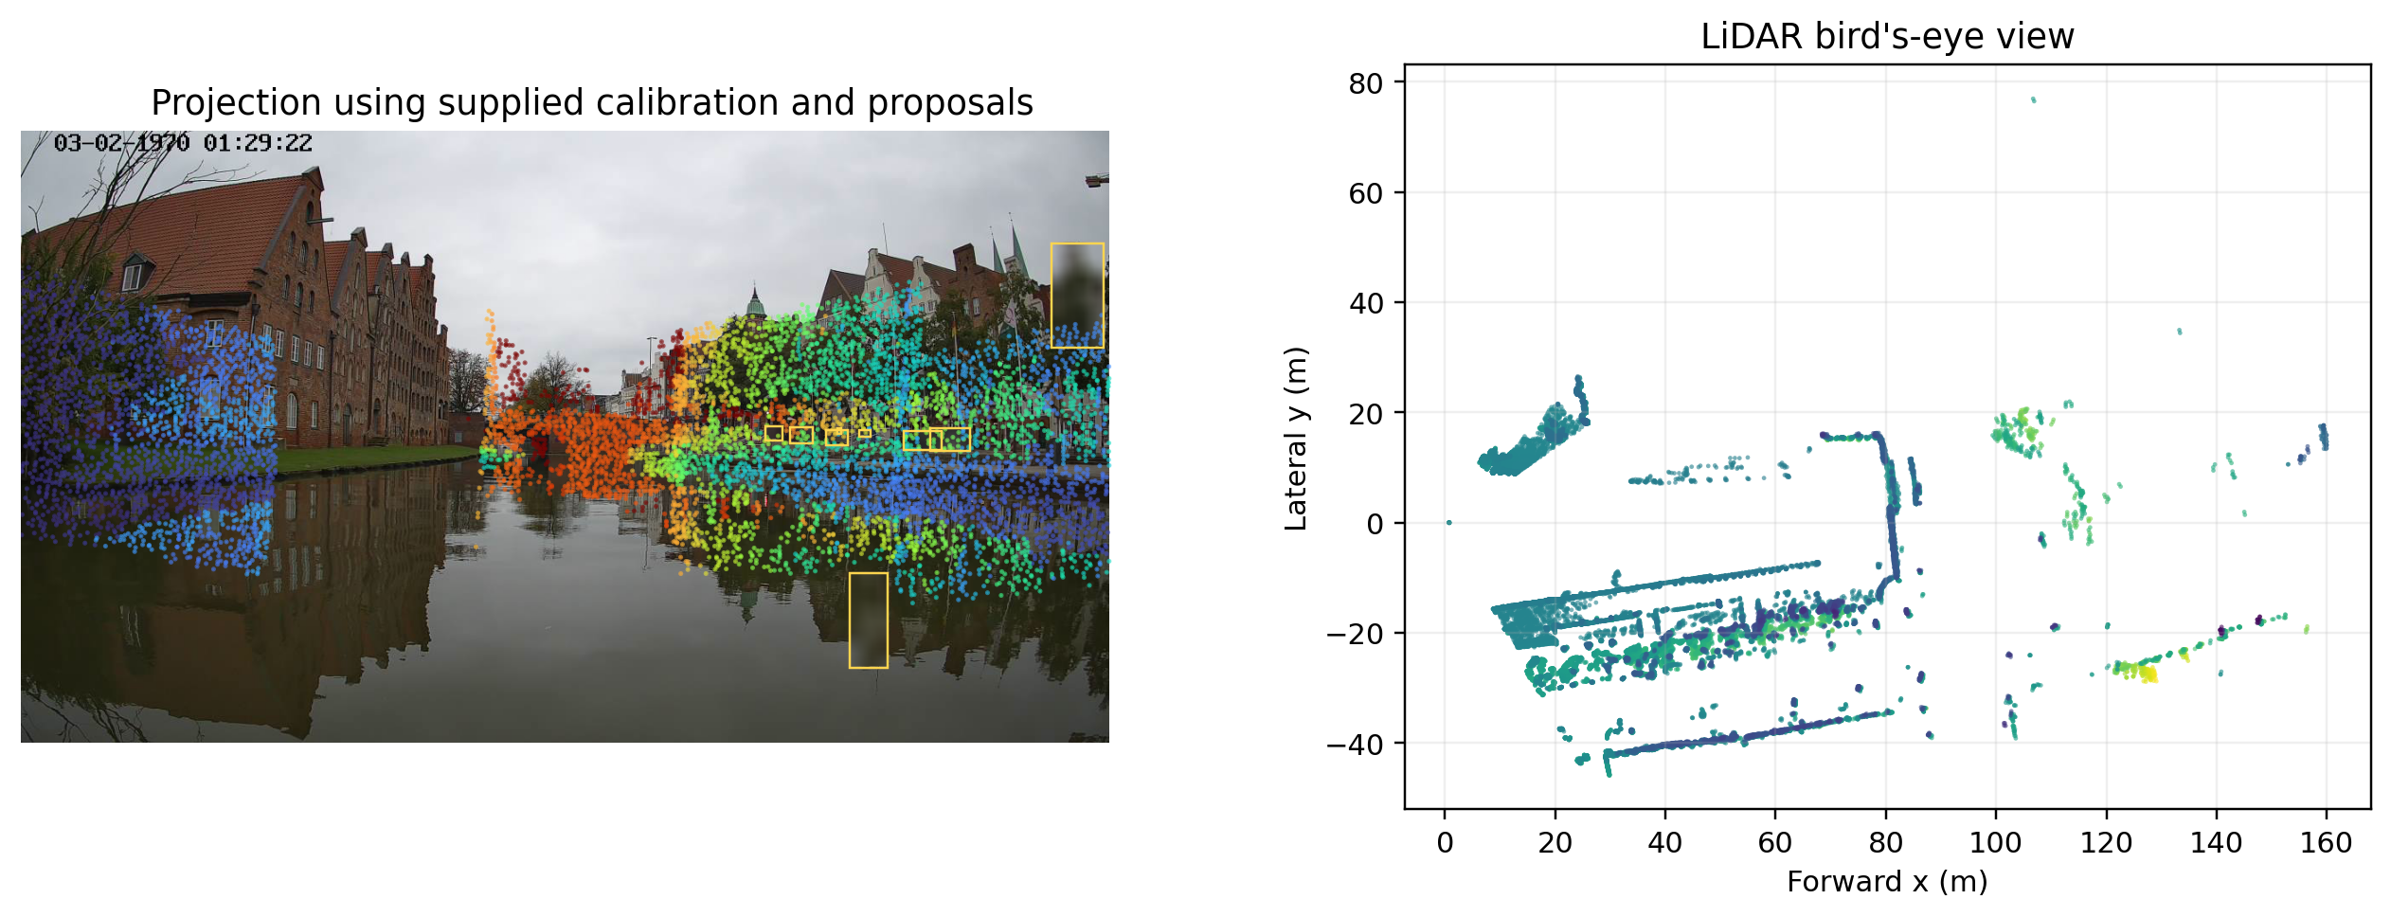
Figure 2 A DAVE Frame With The Supplied Calibration Projection And Privacy Proposals (Left), And The Corresponding Lidar Bird's-Eye View (Right).
Synchronized-pair association and confidence calibration
For each image, the same-stem LiDAR frame formed a positive synchronized pair. Negative pairs were generated by shifting the LiDAR frame by 1, 2, 4, 8, or 16 positions while staying inside the same chronological block. If a forward offset crossed a block boundary, the equivalent backward offset was used. Each image therefore contributed one positive and five negatives, giving 768 pair records. The test block contains 192 records: 32 positives and 160 negatives. These labels represent frame-level synchronization, not object-to-object correspondence.
Image-only and LiDAR-only baselines were standardized logistic regressions. Early summary fusion used a logistic regression on concatenated modality summaries; the late evidence rule used a logistic regression on engineered alignment and proposal-support evidence. Learned fusion was a random forest with 400 trees, depth 5, minimum leaf size 4, and balanced bootstrap weights. Platt calibration was fitted to learned logits on the calibration block. Reliability r was the clipped geometric mean of sharpness, entropy, retained-point, and in-frame-point ratios to synchronized-training medians, set to zero under modality loss. The gate used p_g = 0.5 + r(p_c - 0.5).
Class imbalance was handled through balanced fitting and metrics that separate ranking from probability quality. This choice parallels cost-sensitive fraud detection under extreme imbalance [46] and calibrated rejection workflows [18], but the pair labels here are mechanically generated from frame offsets rather than human adjudication. The confidence gate therefore operates on a fixed calibration block and is evaluated as a selective policy, not as an independently learned detector.
Metrics were AUROC, precision-recall area, balanced accuracy, F1, Brier score, ten-bin expected calibration error (ECE), and descriptive accuracy on the 80% most confident records. Three thousand block-bootstrap replicates resampled the 32 test images; identical blocks were used for paired differences between the uncalibrated learned model and the Platt-calibrated, confidence-gated pipeline. Resampling the source frame rather than its six pair records keeps the synchronized pair and five offsets together. The interval consequently measures sensitivity to which held-out frames were observed; it does not remove the route-level dependence shared by adjacent frames.
Controlled Sensor Conditions And Anomaly Detection
With seed 2026, camera conditions were radius-4 blur, RGB noise with standard deviation 24, brightness 0.35, and loss. LiDAR conditions were 70% point dropout, XYZ noise with standard deviation 0.25 m, and loss. Geometric conditions added 3-degree yaw or 0.50-m lateral translation. Association robustness compared synchronization with four-second mismatch under the same condition.
The operational abstention threshold was the 20th percentile of confidence, 2|p_g - 0.5|, on the calibration block. Condition-specific evaluations recorded the fraction of predictions below this fixed threshold. Thus an abstention rate of one means the policy refused every pair, not that association accuracy was preserved.
Anomaly detectors used only 64 synchronized training frames. Modality, concatenated, residual, and full-feature scores were root-mean-square standardized deviations. Isolation Forest used 400 trees [44], and the gated hybrid added 2.5(1-r) to full-feature distance. The nine evaluated anomalies were camera blur, camera noise, camera loss, LiDAR dropout, LiDAR noise, LiDAR loss, 3-degree extrinsic yaw, 0.50-m extrinsic translation, and a four-second temporal offset; each compared 32 transformed with 32 normal test frames.
Residual and sequence-based anomaly work provides useful design analogies. Unsupervised residual fusion has been used to model noisy-neighbor VM degradation [47]; self-supervised LogBERT-style scoring has been evaluated for log anomalies [48]; and retrieved normal prototypes have been used to explain OpenStack failure-injection anomalies [49]. The DAVE sample is too small and lacks natural failure labels for comparable sequence models, so the implemented detectors remain standardized deviations, Isolation Forest, and a reliability-penalized hybrid.
Proposal association and tracklet continuity
Proposals below score 0.30 or area 40 pixel² were removed, leaving 490. Depth required three projected points. The five rules were center-Hungarian, IoU-Hungarian, two-observation constant-velocity Hungarian, normalized-affinity JPDA-style, and a gated cost. The constant-velocity rule is not a Kalman filter; the JPDA-style rule normalizes exponentiated affinities before Hungarian assignment rather than enumerating classical joint events [29], [30].
The normalized-affinity rule is deliberately labeled JPDA-style because it does not enumerate classical joint association events. A full object-level fusion tracker combining JPDA and EKF [13] represents a stronger probabilistic baseline for datasets with verified detections, state uncertainty, and object identities. Those requirements are absent here, so the present analysis confines itself to link continuity and perturbation recovery.
The gated cost combines predicted-center displacement, one minus IoU, and relative depth change. Low scores increase motion weight; depth weight follows the smaller point count, capped at 20. Category mismatch is penalized, and tracks survive two misses.
Without identities, evaluation uses link rate, starts per 100 proposals, normalized second-order center displacement, depth jumps above 35%, and forward-reverse link-overlap F1. This cycle F1 is not IDF1. Recovery measures retained clean edges and new spurious edges under box jitter, 20% drop, depth loss, score degradation, and a combined condition, averaged over five fixed seeds.

- RESULTS AND DISCUSSION
Synchronized-pair discrimination and calibration

Table 3 Held-Out Synchronized-Pair Association
Method | AUROC | AUPRC | Bal. acc. | Brier | ECE | Sel. acc. @80%
Image only | 0.500 | 0.167 | 0.500 | 0.250 | 0.333 | 0.169
LiDAR only | 0.486 | 0.164 | 0.500 | 0.353 | 0.461 | 0.162
Early summary fusion | 0.471 | 0.149 | 0.500 | 0.813 | 0.821 | 0.175
Late evidence rule | 0.457 | 0.148 | 0.503 | 0.281 | 0.329 | 0.487
Learned fusion | 0.497 | 0.193 | 0.500 | 0.177 | 0.174 | 0.818
Confidence-gated fusion | 0.487 | 0.190 | 0.503 | 0.157 | 0.097 | 0.818

None of the methods reliably ranked synchronized pairs above shifted pairs. Image-only evidence produced a constant score and AUROC 0.5000. LiDAR-only, early summary-fusion, and late evidence-rule AUROCs were 0.4859, 0.4707, and 0.4566. Learned fusion reached 0.4971, while confidence-gated fusion produced 0.4865. Every AUROC frame-bootstrap interval contained 0.5. The positive prevalence was 0.1667, so learned-fusion AUPRC 0.1926 represented only a small increase over the prevalence reference. Balanced accuracy was 0.5000 for learned fusion and 0.5031 for the calibrated-gated pipeline.
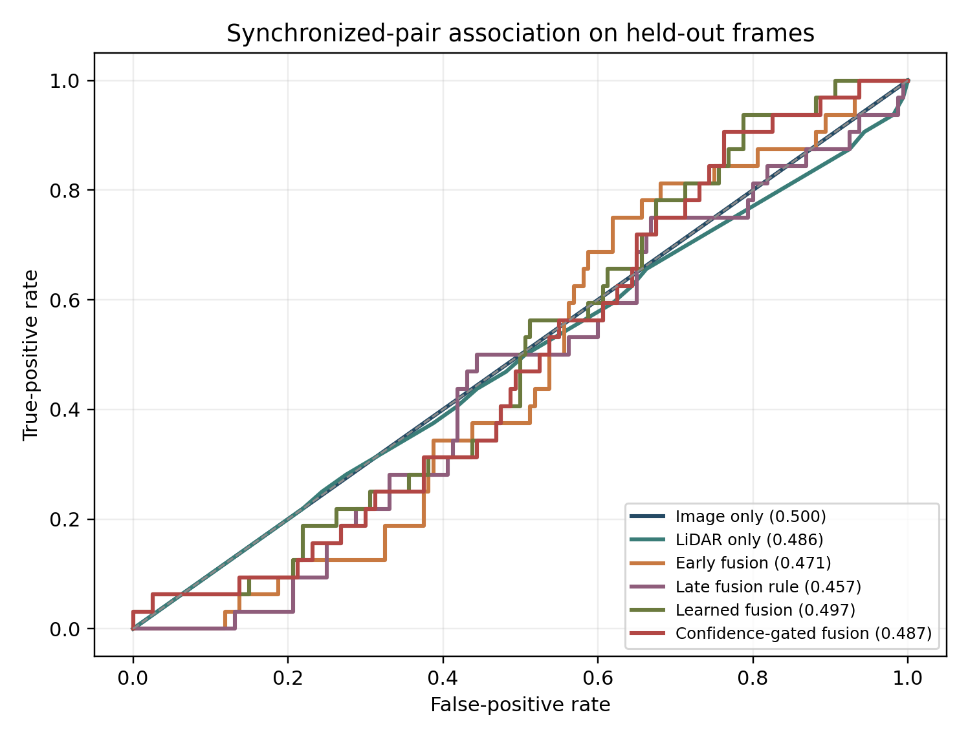
Figure 3 ROC Curves For Synchronized-Pair Association On The Chronological Held-Out Block. The Curves Remain Close To Chance, Exposing The Difficulty Of Temporal Association In This Short, Slowly Varying Sequence.
The 80%-confidence accuracies of learned and gated fusion were both 0.8182, below the 0.8333 accuracy of always predicting the majority negative class. This diagnostic therefore does not establish useful selective skill. The class imbalance also explains why F1 and unbalanced accuracy can look inconsistent with near-chance AUROC. Balanced accuracy, ROC, and precision-recall behavior are the more informative discrimination measures.
Calibration changed even though ranking did not. The Platt-calibrated, confidence-gated pipeline reduced Brier score from 0.1768 to 0.1571 and ten-bin ECE from 0.1743 to 0.0968 relative to the uncalibrated learned model. On identical frame-block bootstrap replicates, the calibrated-gated-minus-uncalibrated Brier difference was −0.0197 with interval [−0.0218, −0.0177], and the ECE difference was −0.0730 with interval [−0.0827, −0.0465]. The individual AUROC intervals were [0.3976, 0.5975] for learned fusion and [0.3904, 0.5830] for calibrated-gated fusion.

Table 4 Frame-Cluster Bootstrap Calibration Intervals
Model/contrast | Metric | Estimate | 95% interval | Resampling unit
Learned fusion | AUROC | 0.497 | [0.398, 0.597] | 3,000 frame-cluster resamples
Learned fusion | BRIER | 0.177 | [0.166, 0.188] | 3,000 frame-cluster resamples
Learned fusion | ECE | 0.174 | [0.161, 0.190] | 3,000 frame-cluster resamples
Confidence-gated fusion | AUROC | 0.487 | [0.390, 0.583] | 3,000 frame-cluster resamples
Confidence-gated fusion | BRIER | 0.157 | [0.147, 0.167] | 3,000 frame-cluster resamples
Confidence-gated fusion | ECE | 0.097 | [0.083, 0.133] | 3,000 frame-cluster resamples
Cal.+gate - raw learned: Brier | Difference | -0.020 | [-0.022, -0.018] | Paired bootstrap
Cal.+gate - raw learned: ECE | Difference | -0.073 | [-0.083, -0.046] | Paired bootstrap
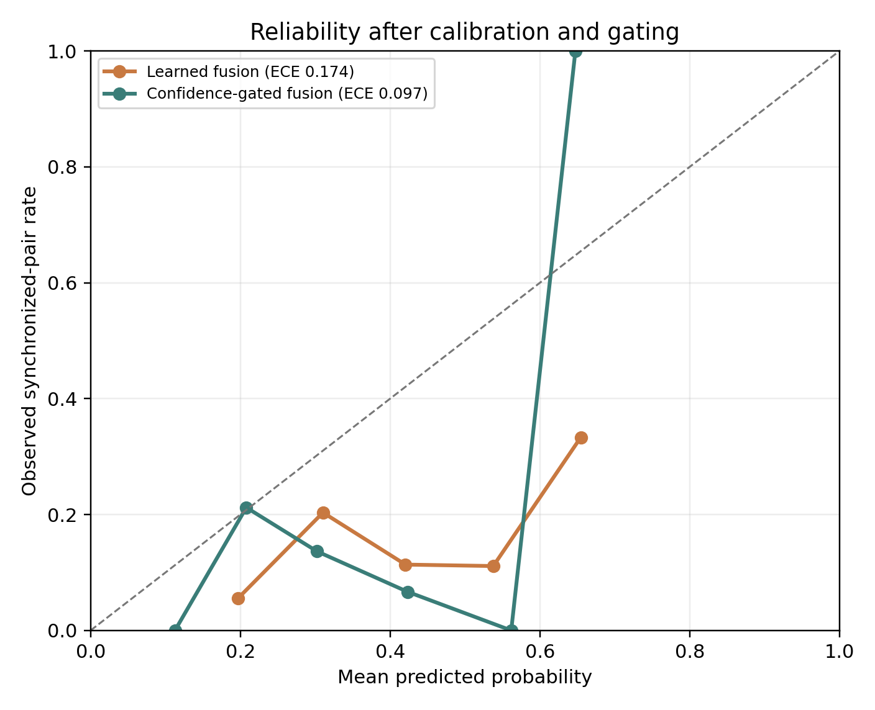
Figure 4 Reliability Diagram For The Uncalibrated Learned Model And Calibrated-Gated Pipeline. ECE Used Ten Bins; The Pipeline Lowered Relative Calibration Error Without Improving Discrimination.
This is calibration without discrimination. Moving scores toward the empirical class rate can improve Brier score even when classes remain intermingled. A constant probability equal to the fixed test prevalence, 1/6, would have Brier score 0.1389, lower than either learned or calibrated-gated fusion. The combined calibration-and-gating pipeline therefore improves relative probability quality over the uncalibrated learned model but does not establish strong absolute calibration or useful association. This distinction agrees with the purpose of post-hoc calibration: it changes the interpretation of scores without necessarily changing their order [16]. Figure 4 uses eight equal-width bins to keep the reliability traces legible; the reported ECE values use the ten-bin definition fixed before evaluation.
Similar distinctions appear in calibrated decision systems. Credit-risk studies couple probability calibration with rejection or explanation [19], [50], while risk-bounded infrastructure policies couple uncertainty envelopes with an explicit admissibility rule [21]. In each case, calibration changes how a score may be acted upon; it does not necessarily create a better ranking. The DAVE result is the perception analogue: score meaning improves relative to the uncalibrated model, but the underlying features still do not separate neighboring frames.
Edge alignment alone gave AUROC 0.5488; adding proposal support raised it to 0.5732, the ablation maximum. Global quality features reduced AUROC to 0.4969. This quality-feature configuration belonged to a separately fitted 300-tree ablation forest, not the 400-tree main learned model. Within the ablation, Platt calibration preserved ranking while reducing Brier score from 0.1831 to 0.1484 and ECE from 0.1838 to 0.0786. Applying the confidence gate after Platt calibration lowered ECE slightly to 0.0764 but worsened AUROC to 0.4807 and Brier score to 0.1521.

Table 5 Association Feature And Calibration Ablation
Variant | AUROC | AUPRC | Brier | ECE | Sel. acc. @80%
Edge alignment | 0.549 | 0.188 | 0.172 | 0.132 | 0.818
+ proposal support | 0.573 | 0.204 | 0.150 | 0.084 | 0.838
+ modality quality | 0.497 | 0.177 | 0.183 | 0.184 | 0.805
+ Platt calibration | 0.497 | 0.177 | 0.148 | 0.079 | 0.818
+ confidence gate | 0.481 | 0.171 | 0.152 | 0.076 | 0.818

Temporal Offsets And Association Under Sensor Shift

Table 6 Temporal-Offset Association Auroc
Offset (s) | Late evidence rule | Learned | Confidence-gated
1 | 0.470 | 0.451 | 0.461
2 | 0.476 | 0.468 | 0.454
4 | 0.435 | 0.405 | 0.400
8 | 0.487 | 0.584 | 0.541
16 | 0.416 | 0.577 | 0.576

Offset response was nonmonotonic: learned AUROC was 0.4512, 0.4678, 0.4053, 0.5840, and 0.5771 from 1 to 16 s. Gating was similar and the late rule stayed near chance. Scene drift became more visible at 8 and 16 s, but smooth riverbank appearance left nearby shifted and same-stem summaries similar.
The nonmonotonic offset curve is compatible with a representation that detects only larger regime changes. Domain-adaptation theory with approximately shared features [15] and empirical cross-cloud transfer results [40] both caution that partial feature overlap can produce uneven gains across targets. Forecasting under changing weather and seasonal regimes [42] gives a further example in which shift magnitude and feature relevance interact. These are methodological analogies rather than evidence that the DAVE sequence contains the same mechanisms.
The negative result is consistent with the representation and route. Global luminance, entropy, projected-point occupancy, and pooled edge relationships discard much of the local structure needed to distinguish neighboring observations. The camera and LiDAR also view the same slowly evolving river corridor, so both a synchronized pair and a nearby mismatch can retain comparable coarse statistics. Proposal support adds some localized evidence, explaining its higher ablation AUROC, but the proposals were produced for privacy processing and are sparse or absent in two frames. A stronger synchronization detector would need local correspondence, scan-aware timing, or motion compensation rather than more confidence processing on the same summaries.
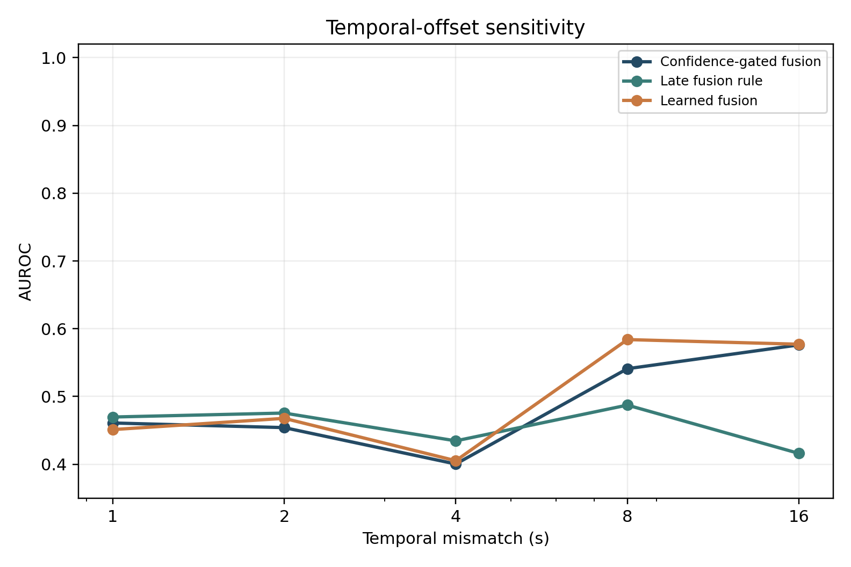
Figure 5 AUROC Versus Camera-Lidar Temporal Mismatch. Offsets Of One To Four Seconds Are Not Resolved Reliably; Learned Evidence Becomes Modestly Informative At Eight And Sixteen Seconds.
Shift did not restore discrimination. Clean four-second AUROC was 0.4053 learned and 0.4004 gated; blur produced 0.4131 and 0.3770, and dropout 0.4141 and 0.3848. Shrinkage sometimes improved Brier or ECE, not ranking. Modality loss forced p_g = 0.5 and full abstention, giving fail-closed behavior rather than preserved accuracy.

Table 7 Association Under Sensor Shift And Selective Abstention
Condition | Learned AUROC | Gated AUROC | Gated ECE | Abstention
Clean | 0.405 | 0.400 | 0.256 | 70.3%
Camera Blur | 0.413 | 0.377 | 0.213 | 98.4%
Camera Noise | 0.491 | 0.487 | 0.136 | 96.9%
Camera Dark | 0.416 | 0.411 | 0.221 | 100.0%
Lidar Dropout | 0.414 | 0.385 | 0.176 | 100.0%
Lidar Noise | 0.575 | 0.511 | 0.275 | 39.1%
Extrinsic Yaw | 0.435 | 0.413 | 0.293 | 40.6%
Extrinsic Translation | 0.474 | 0.453 | 0.243 | 60.9%
Camera Missing | 0.487 | 0.500 | 0.000 | 100.0%
Lidar Missing | 0.475 | 0.500 | 0.000 | 100.0%
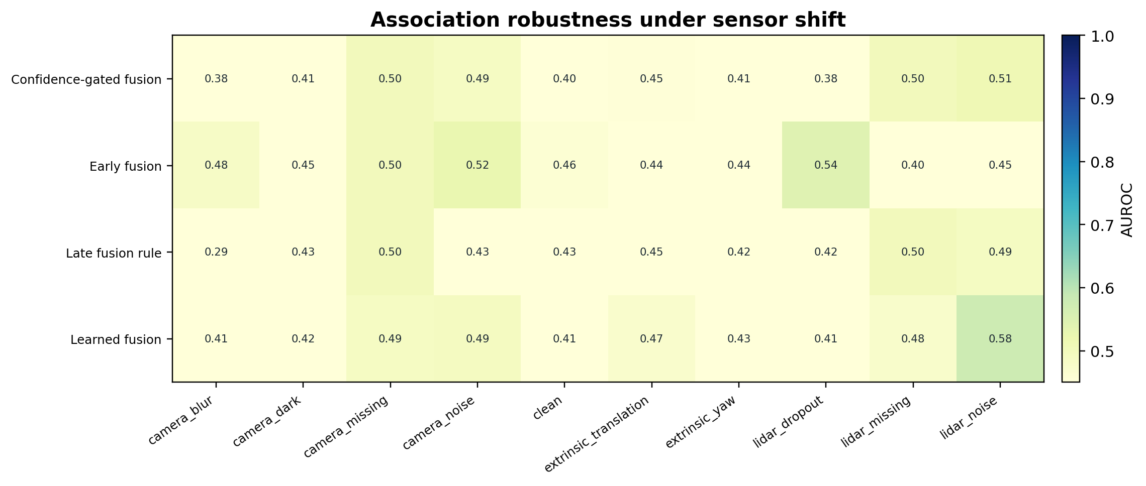
Figure 6 Association AUROC under modality degradation, extrinsic shift, and modality loss. Pair discrimination remains near chance under most shifts; Table VII reports the separate abstention response.
The calibration threshold rejected 70.3% of clean pairs, 98.4% under blur, 96.9% under noise, and all pairs under darkening, dropout, or loss. This conservatism is compatible with an alarm but disrupts continuous association; the adjacent 32-frame calibration block did not represent later confidence [17].
The high clean abstention rate also exposes a deployment issue: a threshold calibrated on an adjacent block may become operationally unusable even when its numerical criterion is fixed. Multi-horizon demand forecasting with operational risk curves [43] and few-shot cold-start adaptation [41] motivate monitoring both coverage and error after deployment. For sensor fusion, the equivalent dashboard should report clean coverage, condition-specific abstention, and post-shift calibration rather than a single threshold.

Frame-Level Anomaly Detection
Table 8 Frame-Level Anomaly-Detection Auroc
Known anomaly | Image z | LiDAR z | Fusion residual | Gated hybrid
Camera Blur | 1.000 | 0.500 | 0.380 | 1.000
Camera Missing | 1.000 | 0.500 | 1.000 | 1.000
Camera Noise | 1.000 | 0.500 | 0.599 | 1.000
Extrinsic Translation | 0.500 | 0.426 | 0.533 | 0.499
Extrinsic Yaw | 0.500 | 0.534 | 0.534 | 0.535
Lidar Dropout | 0.500 | 1.000 | 0.651 | 1.000
Lidar Missing | 0.500 | 1.000 | 1.000 | 1.000
Lidar Noise | 0.500 | 0.373 | 0.610 | 0.627
Temporal Offset 4 | 0.500 | 0.568 | 0.497 | 0.498

Anomaly performance split sharply. Camera statistics perfectly separated the fixed radius-4 blur, noise-standard-deviation-24, and loss conditions from the 32 normal test frames; LiDAR statistics did so for 70% dropout and loss. The gated hybrid retained these results and reached macro AUROC 0.7955, but conspicuous failures dominate that average.
Harder inconsistencies stayed near chance. LiDAR z-score led the four-second offset at 0.5684, Isolation Forest led yaw at 0.5742, and fusion residual led translation at 0.5332. Gated scores were 0.4980, 0.5352, and 0.4990; its LiDAR-noise AUROC 0.6270 ranked random depth changes more reliably than rigid shift.
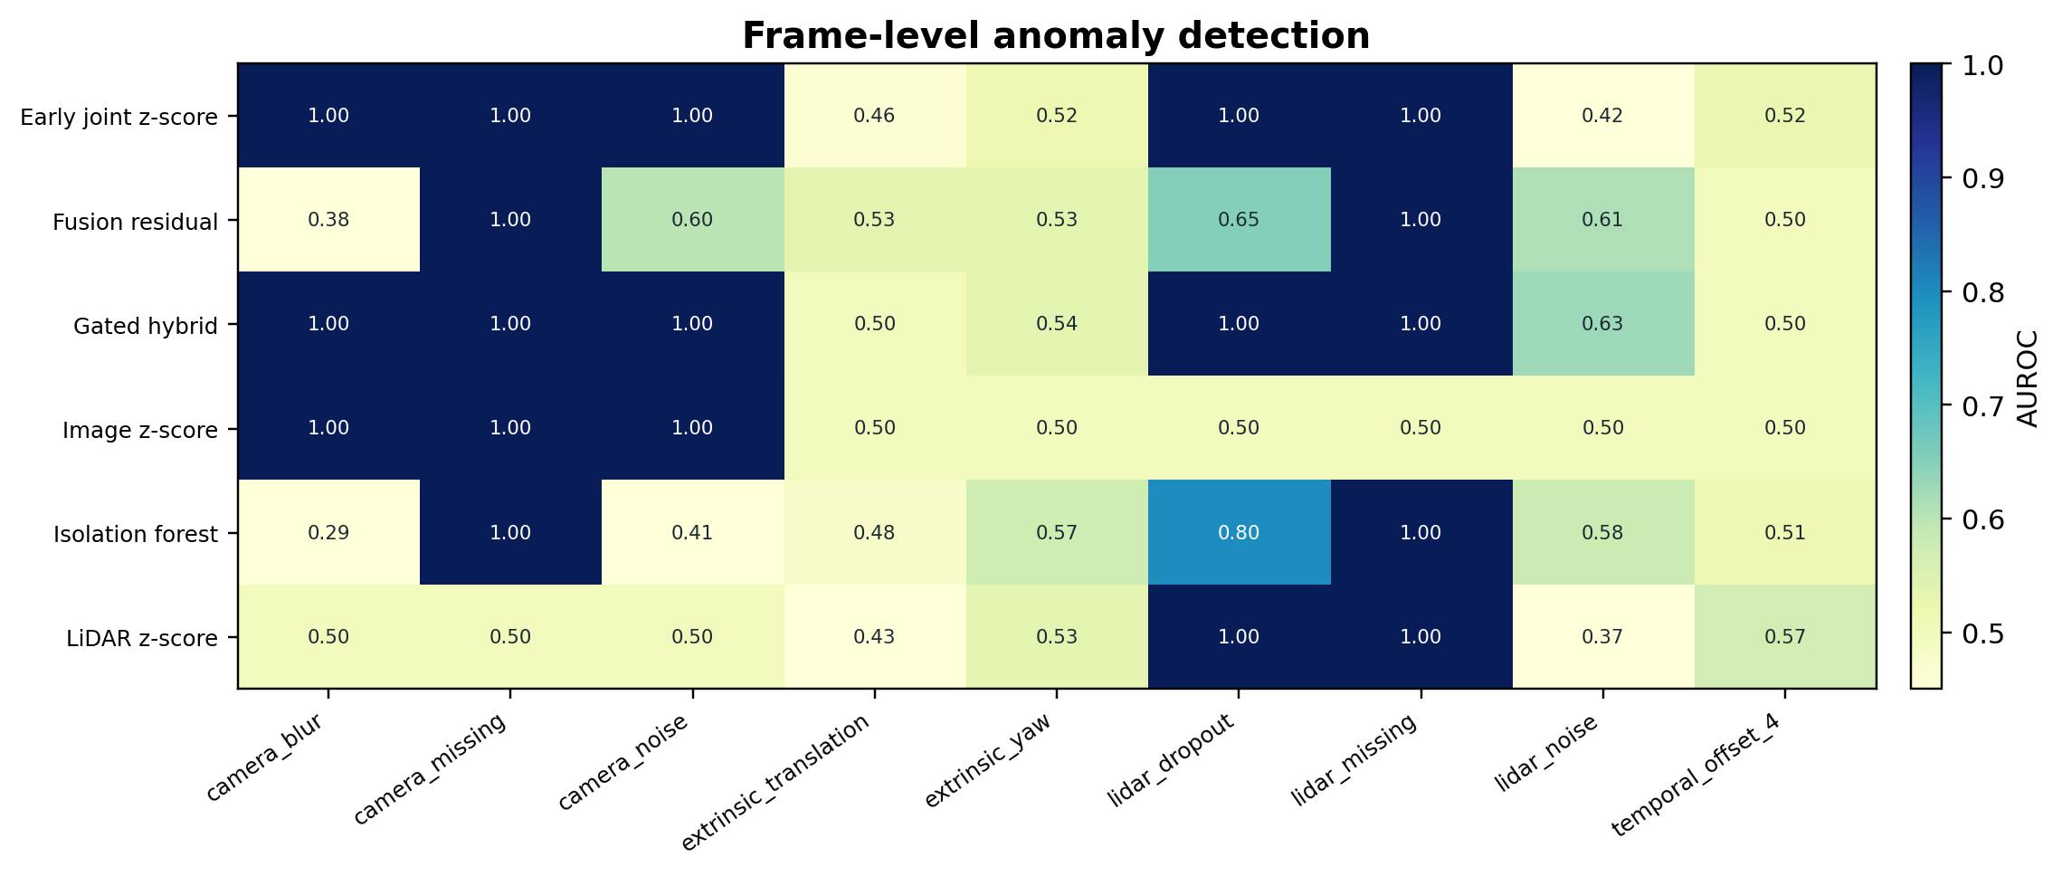
Figure 7 Anomaly-Detection Auroc By Corruption And Detector. Quality Failures Are Separable; Geometric And Temporal Inconsistencies Remain Difficult Without A Surveyed Calibration Target Or Track Labels.
Isolation Forest reached 0.7988 for dropout and 1.0 for absence but only 0.2871 for blur and 0.4072 for camera noise; natural temporal drift sometimes outweighed the transformation. Deep one-class classification offers a higher-capacity alternative [45], but fitting it to only 64 normal frames would not support a dependable comparison here. Fixed severities likewise do not define detectability thresholds.
Operational anomaly pipelines increasingly combine a detector with evidence handoff. Conformal alert control and incident-ticket generation [51] make the alerting policy explicit; retrieved normal prototypes [49] and retrieval-grounded HDFS narratives [52] provide concrete comparison evidence. System-call window localization [53] and smoothed CloudTrail attack-chain stages [54] illustrate how temporal evidence can localize security events. DAVE provides no verified anomaly onset or causal labels, so the present AUROCs measure only separation of predefined transformed frames.
The fixed severe corruptions are also an imbalanced-detection setting: only 32 transformed and 32 normal frames are available per condition. Cost-sensitive and one-class fraud models [46], IoT traffic autoencoders [55], TinyLLM-assisted intrusion detection [56], and language-guided feature selection for CICIDS2017 [57] all emphasize that representation and operating-point choices can dominate headline accuracy. Here, the perfect AUROCs for blur, noise, dropout, and absence should therefore be read as severity-specific separability, not as universal detection rates.
Tracklet Continuity And Controlled Perturbation Recovery
Table 9 Clean-Sequence Proposal-Link Continuity Proxies
Association | Tracks | Link rate | Starts/100 | Cycle F1 | Depth jumps | ms/frame
Center-Hungarian | 141 | 0.712 | 28.78 | 0.696 | 0.039 | 0.162
IoU-Hungarian | 135 | 0.724 | 27.55 | 0.884 | 0.045 | 0.144
Constant-velocity Hungarian | 133 | 0.729 | 27.14 | 0.802 | 0.044 | 0.225
JPDA-style affinity | 119 | 0.757 | 24.29 | 0.823 | 0.050 | 0.169
Confidence-gated | 133 | 0.729 | 27.14 | 0.815 | 0.044 | 0.161

Over 490 proposals, JPDA-style affinity gave the highest link rate (0.7571) and fewest starts (24.29/100); IoU-Hungarian gave the highest cycle F1 (0.8839); and constant velocity gave the lowest acceleration (0.00783). Gating obtained link rate 0.7286, cycle F1 0.8151, and depth-jump rate 0.0442. All median tracklets lasted two observations.
These proxies are not identity accuracy: permissive linking can inflate continuity, and cycle F1 can reward repeated errors. Figure 8 therefore shows image-coordinate proposal histories, not ego-motion-compensated trajectories. Their practical role is diagnostic. Link rate and starts reveal fragmentation, normalized acceleration exposes erratic image-plane motion, and forward–reverse overlap tests whether an association rule is internally stable when time is traversed in either direction. None can determine whether a boat or person retained the correct identity.
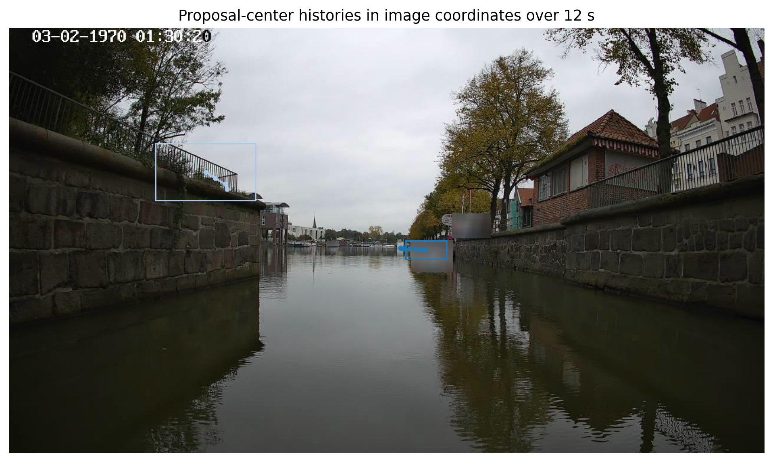
Figure 8 Confidence-Gated Proposal-Center Histories In Image Coordinates Over A 12-Second Segment, Without Ego-Motion Correction. The Display Visualizes Continuity Only; The Sequence Provides No Human Identity Labels For Standard MOT Scoring.
Against each method's clean edges, gating was best under box jitter: retention 0.8006 ± 0.0246 and spurious rate 0.1990 ± 0.0261 over five seeds. Depth and score weighting moderated displaced boxes when cross-modal evidence remained.

Table 10 Tracklet-Link Edge Retention Under Controlled Proposal Perturbations
Condition | Center | IoU | Const.-vel. | Affinity | Gated
Bbox Jitter | 0.699 | 0.756 | 0.751 | 0.771 | 0.801
Combined | 0.732 | 0.753 | 0.745 | 0.756 | 0.747
Detection Drop | 0.809 | 0.903 | 0.900 | 0.925 | 0.879
Lidar Missing | 1.000 | 1.000 | 1.000 | 1.000 | 0.910
Score Degradation | 1.000 | 1.000 | 1.000 | 0.981 | 0.986

Under 20% proposal drop, JPDA-style retention was 0.9245 versus gated 0.8792. Under combined corruption it retained 0.7563, versus IoU 0.7527 and gated 0.7472. Methods that do not use depth produced unchanged edges under depth loss because their costs cannot respond to that input; gating changed its weights and retained 0.9104 of clean edges with spurious rate 0.0947.
The complementary recovery patterns reinforce the distinction between continuity and correctness. The JPDA/EKF object-level study [13] formalizes association uncertainty when tracked objects and measurements are available, whereas the current normalized-affinity proxy can only assess edge persistence. Under box jitter, confidence-weighted depth and score cues preserve more of the method’s own clean graph; under detection loss, a more permissive affinity rule preserves more links. Neither outcome identifies the true object association.
Removing motion raised link rate to 0.7939 and cycle F1 to 0.8557 but worsened acceleration to 0.01179. Removing score raised cycle F1 to 0.8280. No component improves every proxy, reinforcing the need for identities.

Operational Evidence Handoff And Human Oversight
A deployable fusion monitor should not expose a scalar probability alone. Its incident record should identify the affected frame interval, modality health, projected-point retention, alignment residuals, calibration state, abstention reason, and the actions that remain safe. Multi-source root-cause attribution for CPU and network faults [58] and bilingual RAG-based cloud incident triage [59] motivate joining heterogeneous evidence before summarization. Evidence-grounded DevOps question answering [60] further emphasizes that operational claims should remain traceable to private runbooks or measurements.
Generated remediation requires additional controls. Evidence-chain RAG with word-level attribution and provenance explanations [61] and deterministic provenance-oriented variants [62] show how an answer can be bound to cited evidence; evidence-calibrated abstention for unanswerable questions [63] reinforces refusal when coverage is insufficient. A DevOps copilot with command-safety evaluation [64] and cost-aware AIOps routing [65] suggest a tiered policy: deterministic sensor checks first, retrieval-supported diagnosis second, and a larger language model only after evidence and permissions are established.
Human-facing presentation is part of that policy. Scientific-search evidence cards [66], uncertainty-aware medical-image explanation cards [67], privacy and data-integrity risk cards for agents [68], and infrastructure capacity visual briefs [69] each organize confidence, evidence, and recommended action into a compact review surface. Distributed-log incident visualization cards [70] offer the closest operational analogue. For camera–LiDAR monitoring, an evidence card could show sensor status, active shift signature, confidence interval, temporal extent, supporting features, and a fail-safe recommendation while explicitly stating when object identity is unavailable.
Self-verification is useful only when it is constrained by evidence and policy. VerifySafe-style evidence-based response checking [71] provides one model for adversarial or ambiguous prompts, while hybrid cloud deployment architectures [72] show how lightweight local components and larger remote models can be separated operationally. In the present setting, the numerical detector and gate should remain authoritative; any language layer should summarize their outputs and must not manufacture target identities, calibration certificates, or remediation commands.
Computational Cost And Study Limits
Table 11 Measured Computational Cost
Component | Unit | Milliseconds
Feature extraction and fusion | pair | 61.7084
Inference: Image only | pair | 0.0070
Inference: LiDAR only | pair | 0.0044
Inference: early summary fusion | pair | 0.0038
Inference: late evidence rule | pair | 0.0036
Inference: Learned fusion | pair | 0.4462
Link proxy: center-Hungarian | frame | 0.1625
Link proxy: IoU-Hungarian | frame | 0.1436
Link proxy: constant-velocity Hungarian | frame | 0.2247
Link proxy: normalized affinity | frame | 0.1687
Link proxy: confidence-gated | frame | 0.1611
Feature extraction, projection, and fusion-feature construction required 61.71 ms per pair in the amortized measured run. Learned-fusion inference required 0.446 ms per pair; logistic baselines required 0.0036–0.0070 ms. Temporal association proxies required 0.144–0.225 ms per frame. These numbers exclude generation of the supplied proposals, file decompression, and any detector or neural feature encoder. Without a hardware manifest and repeated benchmarking, they should not be generalized as deployment throughput.
The timing profile suggests that deployment optimization should focus on feature construction rather than classifier inference. TinyLLM-assisted intrusion detection [56], language-guided feature selection [57], distilled edge quality prediction [26], and parameter-efficient cross-modal pretraining [24] all follow a similar pattern: keep the first-stage representation compact and reserve heavier models for escalated cases. A hybrid cloud–edge architecture [72] and cost-aware AIOps routing [65] provide plausible systems patterns, but the measured DAVE timings do not include detector generation, network transfer, or a language model.
The experiments support three linked conclusions. First, the supplied calibration yields useful projected statistics and proposal-depth descriptions, but aggregate evidence does not identify exact synchronization reliably in a short, slowly changing route. Second, the Platt-calibrated, confidence-gated pipeline reduces Brier score and ECE relative to the uncalibrated learned model on the held-out block even while AUROC remains at chance; the separate ablation attributes most of this probability-quality gain to Platt calibration. Third, robustness is condition-specific: the fixed severe sensor-health failures are visible, fixed geometric shifts remain difficult, confidence gating gives the best jitter edge-retention proxies, and normalized affinity preserves more continuity when proposals disappear.
The study covers one autocorrelated 127-s run, one rig, and fixed transformations. The projection is not surveyed ground truth. DAVE lacks identities, ego poses, 3D boxes, real anomaly events, per-point time, ring index, and reflectivity; the privacy proposals remain unverified. These omissions constrain the evaluation to frame pairing, anomaly scores, and tracklet-continuity proxies rather than detector AP or identity-based tracking metrics. Repeated annotated trips, ego-motion compensation, richer points, and surveyed calibration regimes are needed.
Future validation should therefore be organized around repeated routes and explicit transfer. Cross-cloud transfer results [40] and approximately shared-feature analysis [15] suggest measuring target support and negative transfer, while calibrated risk policies [20], [21] suggest monitoring post-deployment coverage and violations. For tracking, annotated identities would allow the JPDA/EKF and deep-fusion baselines to be evaluated with HOTA or IDF1 rather than internal continuity proxies.
- CONCLUSIONS
A confidence-calibrated camera–LiDAR pipeline was fitted and calibrated on the first 96 DAVE triplets, then evaluated for synchronized pairing and sensor anomalies on the final 32. Proposal-tracklet continuity used the complete 128-frame sequence. Exact synchronization was not reliably distinguishable from shifted pairing: learned and calibrated-gated fusion produced AUROCs 0.4971 and 0.4865. The Platt-calibrated, confidence-gated pipeline reduced Brier score from 0.1768 to 0.1571 and expected calibration error from 0.1743 to 0.0968 relative to the uncalibrated learned model on the held-out block. The paired frame-bootstrap intervals for both differences excluded zero, demonstrating a within-sequence relative calibration benefit without a ranking benefit; the separate ablation showed that Platt calibration supplied most of the gain.
The fixed severe blur, camera-noise, point-dropout, and complete-loss conditions were perfectly separated on this held-out block, but four-second offsets and fixed extrinsic changes remained close to chance. Temporal continuity showed complementary behavior: JPDA-style affinity linked more proposals and recovered best from detection loss, while confidence gating preserved the most clean edges under box jitter. Since DAVE contains no object identities, these results concern continuity and controlled perturbation recovery rather than ground-truth multi-object tracking accuracy. The appropriate next step is to combine richer synchronization evidence with calibrated abstention and validate both association and tracking on independently annotated sequences.

- REFERENCES
- X. Chen, H. Ma, J. Wan, B. Li, and T. Xia, "Multi-view 3D object detection network for autonomous driving," in Proc. IEEE Conf. Comput. Vis. Pattern Recognit. (CVPR), 2017, pp. 6526-6534, doi: 10.1109/CVPR.2017.691.
- J. Ku, M. Mozifian, J. Lee, A. Harakeh, and S. L. Waslander, "Joint 3D proposal generation and object detection from view aggregation," in Proc. IEEE/RSJ Int. Conf. Intell. Robots Syst. (IROS), 2018, pp. 5750-5757, doi: 10.1109/IROS.2018.8594049.
- V. A. Sindagi, Y. Zhou, and O. Tuzel, "MVX-Net: Multimodal VoxelNet for 3D object detection," in Proc. IEEE Int. Conf. Robot. Autom. (ICRA), 2019, pp. 7276-7282, doi: 10.1109/ICRA.2019.8794195.
- S. Vora, A. H. Lang, B. Helou, and O. Beijbom, "PointPainting: Sequential fusion for 3D object detection," in Proc. IEEE/CVF Conf. Comput. Vis. Pattern Recognit. (CVPR), 2020, pp. 4603-4611, doi: 10.1109/CVPR42600.2020.00466.
- S. Pang, D. Morris, and H. Radha, "CLOCs: Camera-LiDAR object candidates fusion for 3D object detection," in Proc. IEEE/RSJ Int. Conf. Intell. Robots Syst. (IROS), 2020, pp. 10386-10393, doi: 10.1109/IROS45743.2020.9341791.
- X. Bai et al., "TransFusion: Robust LiDAR-camera fusion for 3D object detection with transformers," in Proc. IEEE/CVF Conf. Comput. Vis. Pattern Recognit. (CVPR), 2022, pp. 1080-1089, doi: 10.1109/CVPR52688.2022.00116.
- Z. Liu, H. Tang, A. Amini, X. Yang, H. Mao, D. Rus, and S. Han, "BEVFusion: Multi-task multi-sensor fusion with unified bird's-eye view representation," in Proc. IEEE Int. Conf. Robot. Autom. (ICRA), 2023, pp. 2774-2781, doi: 10.1109/ICRA48891.2023.10160968.
- K. Yu et al., "Benchmarking the robustness of LiDAR-camera fusion for 3D object detection," in Proc. IEEE/CVF Conf. Comput. Vis. Pattern Recognit. Workshops (CVPRW), 2023, pp. 3188-3198, doi: 10.1109/CVPRW59228.2023.00321.
- M. Bijelic, T. Gruber, F. Mannan, F. Kraus, W. Ritter, K. Dietmayer, and F. Heide, "Seeing through fog without seeing fog: Deep multimodal sensor fusion in unseen adverse weather," in Proc. IEEE/CVF Conf. Comput. Vis. Pattern Recognit. (CVPR), 2020, pp. 11679-11689, doi: 10.1109/CVPR42600.2020.01170.
- G. Pandey, J. R. McBride, S. Savarese, and R. M. Eustice, "Automatic extrinsic calibration of vision and lidar by maximizing mutual information," J. Field Robot., vol. 32, no. 5, pp. 696-722, 2015, doi: 10.1002/rob.21542.
- X. Lv, B. Wang, Z. Dou, D. Ye, and S. Wang, "LCCNet: LiDAR and camera self-calibration using cost volume network," in Proc. IEEE/CVF Conf. Comput. Vis. Pattern Recognit. Workshops (CVPRW), 2021, pp. 2888-2895, doi: 10.1109/CVPRW53098.2021.00324.
- Q. Xin, “Uncertainty-Aware Late Fusion for 3D Perception (Confidence Calibration + Fusion Rule Learning),” J. Technol. Informatics Eng., vol. 4, no. 1, pp. 215–238, Feb. 2025, doi: 10.51903/jtie.v4i1.485.
- Q. Xin, “LiDAR–Camera Object-Level Fusion for Multi-Target Tracking Using JPDA and EKF: A Reproducible Empirical Study on a PandaSet-Parameterised Five-Sequence Dataset,” J. Technol. Informatics Eng., vol. 5, no. 1, pp. 54–76, Apr. 2026, doi: 10.51903/jtie.v5i1.486.
- Z. Ling, Q. Xin, Y. Lin, G. Su, and Z. Shui, “Optimization of Autonomous Driving Image Detection Based on RFAConv and Triplet Attention,” arXiv:2407.09530, 2024, doi: 10.48550/arXiv.2407.09530.
- Z. S. Zhong, X. Pan, and Q. Lei, “Bridging Domains with Approximately Shared Features,” in Proc. 28th Int. Conf. Artif. Intell. Stat. (AISTATS), PMLR, vol. 258, 2025, pp. 559–567.
- C. Guo, G. Pleiss, Y. Sun, and K. Q. Weinberger, "On calibration of modern neural networks," in Proc. 34th Int. Conf. Mach. Learn., PMLR, vol. 70, 2017, pp. 1321-1330.
- Y. Ovadia et al., "Can you trust your model's uncertainty? Evaluating predictive uncertainty under dataset shift," in Advances in Neural Information Processing Systems, vol. 32, 2019, pp. 13969-13980, arXiv:1906.02530.
- Y. Chen, Y. Zhang, D. Chau, and M. Sherman, “Credit Card Default Risk Tiering with Probability Calibration and Uncertainty-Driven Rejection: A Reproducible Study on the UCI Credit Card Clients Dataset,” J. Adv. Comput. Syst., vol. 3, no. 4, pp. 31–47, Apr. 2023, doi: 10.69987/JACS.2023.30403.
- J. Jin, T. Huang, and S. Lu, “A Model-Risk-Friendly Probability of Default Workflow: Calibration, Distribution-Free Uncertainty Quantification, and SHAP Explanations on the UCI Credit Card Default Dataset,” J. Adv. Comput. Syst., vol. 4, no. 6, pp. 74–85, Jun. 2024, doi: 10.69987/JACS.2024.40606.
- S. He, H. Tu, and I. Liu, “Safe PD Capacity Forecasting with Time-Series Foundation Models and Calibrated Uncertainty for Heterogeneous GPU Clusters,” J. Adv. Comput. Syst., vol. 3, no. 4, pp. 48–66, Apr. 2023, doi: 10.69987/JACS.2023.30404.
- S. Chen, S. He, and E. Sun, “Risk-Bounded GPU Resource Oversubscription via Conformal Demand Envelopes in Production AI Clusters,” J. Adv. Comput. Syst., vol. 4, no. 5, pp. 119–134, May 2024, doi: 10.69987/JACS.2024.40509.
- N. Neverova, C. Wolf, G. W. Taylor, and F. Nebout, "ModDrop: Adaptive multi-modal gesture recognition," IEEE Trans. Pattern Anal. Mach. Intell., vol. 38, no. 8, pp. 1692-1706, Aug. 2016, doi: 10.1109/TPAMI.2015.2461544.
- J.-H. Choi and J.-S. Lee, "EmbraceNet: A robust deep learning architecture for multimodal classification," Inf. Fusion, vol. 51, pp. 259-270, Nov. 2019, doi: 10.1016/j.inffus.2019.02.010.
- G. Mi, T. Ye, and D. Wood, “A Lightweight Medical Foundation Model for Cross-Modal Multi-Task Pretraining and Parameter-Efficient Few-Shot Transfer on MedMNIST,” J. Technol. Informatics Eng., vol. 4, no. 3, pp. 572–589, Aug. 2025, doi: 10.51903/jtie.v4i3.492.
- S. Lu and T. Zou, “Uncertainty-Aware Medical Vision–Language Classification on a Lightweight MedMNIST-Compatible Biomedical Patch Benchmark,” J. Technol. Informatics Eng., vol. 5, no. 2, pp. 1–19, Jun. 2026, doi: 10.51903/jtie.v5i2.530.
- B. Zhou, H. Wang, and X. Chang, “Distilling VMAF into an Edge-Deployable Quality Predictor: A Pilot Shot-Level Proxy with LLM-Ready Quality Tokens,” J. Technol. Informatics Eng., vol. 4, no. 2, pp. 447–463, Aug. 2025, doi: 10.51903/jtie.v4i2.522.
- R. E. Kalman, "A new approach to linear filtering and prediction problems," J. Basic Eng., vol. 82, no. 1, pp. 35-45, Mar. 1960, doi: 10.1115/1.3662552.
- H. W. Kuhn, "The Hungarian method for the assignment problem," Naval Res. Logist. Quart., vol. 2, nos. 1-2, pp. 83-97, Mar. 1955, doi: 10.1002/nav.3800020109.
- T. E. Fortmann, Y. Bar-Shalom, and M. Scheffe, "Sonar tracking of multiple targets using joint probabilistic data association," IEEE J. Oceanic Eng., vol. OE-8, no. 3, pp. 173-184, Jul. 1983, doi: 10.1109/JOE.1983.1145560.
- Y. Bar-Shalom, F. Daum, and J. Huang, "The probabilistic data association filter," IEEE Control Syst. Mag., vol. 29, no. 6, pp. 82-100, Dec. 2009, doi: 10.1109/MCS.2009.934469.
- A. Bewley, Z. Ge, L. Ott, F. Ramos, and B. Upcroft, "Simple online and realtime tracking," in Proc. IEEE Int. Conf. Image Process. (ICIP), 2016, pp. 3464-3468, doi: 10.1109/ICIP.2016.7533003.
- X. Weng, J. Wang, D. Held, and K. Kitani, "3D multi-object tracking: A baseline and new evaluation metrics," in Proc. IEEE/RSJ Int. Conf. Intell. Robots Syst. (IROS), 2020, pp. 10359-10366, doi: 10.1109/IROS45743.2020.9341164.
- A. Kim, A. Osep, and L. Leal-Taixe, "EagerMOT: 3D multi-object tracking via sensor fusion," in Proc. IEEE Int. Conf. Robot. Autom. (ICRA), 2021, pp. 11315-11321, doi: 10.1109/ICRA48506.2021.9562072.
- X. Wang, C. Fu, Z. Li, Y. Lai, and J. He, "DeepFusionMOT: A 3D multi-object tracking framework based on camera-LiDAR fusion with deep association," IEEE Robot. Autom. Lett., vol. 7, no. 3, pp. 8260-8267, Jul. 2022, doi: 10.1109/LRA.2022.3187264.
- J. Luiten, A. Osep, P. Dendorfer, P. H. S. Torr, A. Geiger, L. Leal-Taixe, and B. Leibe, "HOTA: A higher order metric for evaluating multi-object tracking," Int. J. Comput. Vis., vol. 129, no. 2, pp. 548-578, Feb. 2021, doi: 10.1007/s11263-020-01375-2.
- Technical University of Applied Sciences Luebeck, J.-P. Schreiter, and H. Hellbrueck, "DAVE--Image and Pointcloud Data for Fusion," Zenodo, ver. 1, May 27, 2024, doi: 10.5281/zenodo.11349368.
- J.-P. Schreiter, J. Kugler, A. Schmitz, F. Ballin, A. Hessler, and H. Hellbrueck, "Inland waterway vessel autonomy: Sensor and communication design," in Proc. OCEANS 2024 Singapore, 2024, pp. 1-9, doi: 10.1109/OCEANS51537.2024.10682262.
- J.-P. Schreiter and H. Hellbrueck, "Sensor fusion for object localization with ROS 2," in Proc. 5th KuVS/GI Expert Talk on Localization, M. Cimdins, H. Hellbrueck, and H. Sternberg, Eds. Hamburg, Germany: HafenCity University, 2024, pp. 43-46, doi: 10.34712/142.51.
- R. Schlonsak, J.-P. Schreiter, and H. Hellbrueck, "Bridge detection in autonomous shipping: A YOLOv8 approach with Autodistill and GroundedSAM," J. Phys.: Conf. Ser., vol. 2867, no. 1, Art. no. 012019, 2024, doi: 10.1088/1742-6596/2867/1/012019.
- S. He, X. Chang, and E. Sun, “Cross-Cloud Transfer Learning for AI Training Capacity Forecasting under Workload and Topology Distribution Shift,” J. Adv. Comput. Syst., vol. 4, no. 1, pp. 100–120, Jan. 2024, doi: 10.69987/JACS.2024.40108.
- S. He, C. Li, and H. Rao, “Few-Shot Cold-Start Workload Forecasting for New AI Inference Tenants with Time-Series Foundation Models,” J. Technol. Informatics Eng., vol. 4, no. 1, pp. 306–324, Apr. 2025, doi: 10.51903/jtie.v4i1.546.
- Q. Xin, “Probabilistic Bike-Sharing Demand Forecasting under Changing Weather and Seasonal Regimes with Transformer-Based Models,” Transp. Findings, Mar. 2026, doi: 10.32866/001c.157499.
- S. Zhao, J. Bai, and D. Roberson, “Multi-Horizon GPU Demand Forecasting with Workload Semantics and Operational Risk Curves: An Empirical Study on Alibaba Clusterdata GPU Trace,” J. Technol. Informatics Eng., vol. 4, no. 3, pp. 544–571, Dec. 2025, doi: 10.51903/jtie.v4i3.498.
- F. T. Liu, K. M. Ting, and Z.-H. Zhou, "Isolation forest," in Proc. 8th IEEE Int. Conf. Data Mining (ICDM), 2008, pp. 413-422, doi: 10.1109/ICDM.2008.17.
- L. Ruff, R. A. Vandermeulen, N. Goernitz, L. Deecke, S. A. Siddiqui, A. Binder, E. Mueller, and M. Kloft, "Deep one-class classification," in Proc. 35th Int. Conf. Mach. Learn., PMLR, vol. 80, 2018, pp. 4393-4402, arXiv:1802.06360.
- J. Jin, T. Huang, and S. Lu, “Cost-Sensitive Learning, Simulated PU Learning, and One-Class Autoencoding for Extreme-Imbalance Credit Card Fraud Detection,” J. Adv. Comput. Syst., vol. 4, no. 6, pp. 64–73, Jun. 2024, doi: 10.69987/JACS.2024.40605.
- J. Nie and D. Zheng, “Noisy-Neighbor-Aware VM Degradation Risk Modeling with Unsupervised Residual Fusion,” J. Adv. Comput. Syst., vol. 4, no. 4, pp. 112–123, Apr. 2024, doi: 10.69987/JACS.2024.40409.
- Q. Xin, “Self-Supervised Log Anomaly Detection with LogBERT-Style Transformers: Full Empirical Evaluation on a Reproducible SynHDFS Benchmark,” J. Electr. Eng. Comput. Sci., vol. 11, no. 1, pp. 23–35, Jun. 2026, doi: 10.54732/jeecs.v11i1.3.
- Q. Xin, “Explaining OpenStack Failure-Injection Log Anomalies with Retrieved Normal Prototypes,” Emerg. Inf. Sci. Technol., vol. 6, no. 2, pp. 125–146, Nov. 2025, doi: 10.18196/eist.v6i2.31232.
- Q. Xin, “Explainable and Fair Credit Risk Scoring with Counterfactual Explanations: A Reproducible Evaluation on the German Credit Dataset (HELOC-Motivated),” J. Inf. Technol., vol. 14, no. 2, Jun. 2026, doi: 10.32664/j-intech.v14i02.2228.
- Q. Xin, “Log Anomaly Detection with Conformal Alert Control and Evidence-Grounded Incident Ticket Generation,” AVITEC, vol. 8, no. 2, pp. 247–264, May 2026, doi: 10.28989/avitec.v8i2.3974.
- [52] X. Sun, Z. S. Zhong, and Q. Wu, “Retrieval-Grounded HDFS Log Anomaly Detection and Deterministic Failure Narrative Generation,” J. Comput. Syst. Appl., vol. 3, no. 1, pp. 15–30, Jun. 2026, doi: 10.64229/j6d7fr94.
- Q. Xin, “Host-Based Intrusion Detection with System Call Sequences: Window Localization and Forensic Narratives,” AVITEC, vol. 8, no. 2, Jun. 2026, doi: 10.28989/avitec.v8i2.3973.
- J. Bai, S. Chen, D. Zheng, and M.-J. Kuo, “Interpretable Attack-Chain Stage Detection from AWS CloudTrail Event Sequences via Linear Models and HMM Smoothing,” Inf. Electr. Electron. Eng., vol. 6, no. 1, pp. 28–43, May 2026, doi: 10.33474/infotron.v6i1.24923.
- Q. Xin, Z. Xu, L. Guo, F. Zhao, and B. Wu, “IoT Traffic Classification and Anomaly Detection Method Based on Deep Autoencoders,” in Proc. 6th Int. Conf. Comput. Data Sci. (CDS), 2024.
- S. Lu and D. Zhou, “TinyLLM-Assisted Intrusion Detection for Real-Time IoT Networks,” J. Adv. Comput. Syst., vol. 4, no. 8, pp. 72–87, Aug. 2024, doi: 10.69987/JACS.2024.40809.
- Y. Li and S. Lu, “Language-Guided Feature Selection for DDoS and Intrusion Detection on CICIDS2017,” J. Technol. Informatics Eng., vol. 4, no. 1, pp. 284–305, Apr. 2025, doi: 10.51903/jtie.v4i1.531.
- G. Liu, S. He, and I. Liu, “LLM-Augmented Multi-Source Root Cause Attribution for CPU and Network Faults in Microservices,” J. Adv. Comput. Syst., vol. 3, no. 6, pp. 39–57, Jun. 2023, doi: 10.69987/JACS.2023.30604.
- G. Liu, C. Li, and E. Zhang, “OpsLLM for Cloud Incident Triage: Bilingual RAG-Based Root Cause Analysis and Alert Summarization for AI Infrastructure Operations,” J. Adv. Comput. Syst., vol. 4, no. 4, pp. 97–111, Apr. 2024, doi: 10.69987/JACS.2024.40408.
- B. Zhang, H. Rao, and D. Zhao, “Evidence-Grounded RAG for Cloud-Native DevOps: Hallucination-Resistant AIOps Question Answering over Private Operations Documents,” J. Adv. Comput. Syst., vol. 4, no. 3, pp. 109–125, Mar. 2024, doi: 10.69987/JACS.2024.40308.
- C. Li, J. Bai, and S. Wang, “Evidence-Chain Reliable RAG: Word-Level Hallucination Detection, Source Attribution, and Provenance Explanation for LLM Applications,” J. Adv. Comput. Syst., vol. 4, no. 2, pp. 76–92, Feb. 2024, doi: 10.69987/JACS.2024.40207.
- J. Jin, “Evidence-Chain Reliable RAG: Hallucination Detection, Source Attribution, and Deterministic Provenance Explanations,” J. Technol. Informatics Eng., vol. 4, no. 2, pp. 520–533, Aug. 2025, doi: 10.51903/jtie.v4i2.535.
- Z. S. Zhong, J. Chen, E. Zhong, and X. Sun, “Evidence-Calibrated RAG for Unanswerable Question Answering: Retrieval Coverage, Abstention Calibration, and Hallucination-Proxy Analysis on SQuAD 2.0,” J. Technol. Informatics Eng., vol. 4, no. 2, pp. 502–520, Aug. 2025, doi: 10.51903/jtie.v4i2.536.
- B. Zhang, X. Sun, G. Liu, and B. Zhou, “LLM-Style DevOps Copilot for Cloud-Native Troubleshooting: Retrieval-Augmented Runbook Generation and Command-Safety Evaluation,” J. Technol. Informatics Eng., vol. 5, no. 2, pp. 104–118, Aug. 2026, doi: 10.51903/jtie.v5i2.534.
- C. Li, G. Liu, and Z. Zhao, “Cost-Aware LLM-Style Routing for AIOps Log Analysis: Log Parsing, Anomaly Detection, Fault Diagnosis, and Incident Summarization on LogEval Task Files,” J. Technol. Informatics Eng., vol. 5, no. 2, pp. 91–103, Jun. 2026, doi: 10.51903/jtie.v5i2.538.
- J. Jin, “LLM-Style Evidence Cards for Scientific Search Interfaces: A UI/UX Design Framework for Retrieval Transparency, Ranking Trust, and Visual Evidence Hierarchy,” Int. J. Graph. Des., vol. 3, no. 2, pp. 397–414, Oct. 2025, doi: 10.51903/ijgd.v3i2.3698.
- Z. S. Zhong, Q. Wu, and G. Mi, “Uncertainty-Aware Medical Image Explanation Cards: LLM-Generated Visual Explanations for AI-Assisted Radiology Interfaces,” Int. J. Graph. Des., vol. 3, no. 2, pp. 415–436, Oct. 2025, doi: 10.51903/ijgd.v3i2.3616.
- W. Su, H. Rao, and E. Ma, “Privacy and Data-Integrity Risk Cards for LLM Agents: A UI/UX Design Framework for Secure Human Oversight under Prompt-Injection Attacks,” Int. J. Graph. Des., vol. 4, no. 1, pp. 186–191, Apr. 2026, doi: 10.51903/ijgd.v4i1.3699.
- G. Liu, S. He, and H. Wong, “LLM-Compatible Visual Brief Cards for AI Infrastructure Capacity Dashboards: A UI/UX Framework for Turning Forecast Risk into Graphic Design Decisions,” Int. J. Graph. Des., vol. 3, no. 1, pp. 196–213, May 2025, doi: 10.51903/ijgd.v3i1.3723.
- J. Nie, G. Liu, C. Li, and T. Zou, “Evidence-Constrained Incident Visualization Cards for Distributed Cloud Logs: A UI/UX Framework for Turning Hadoop, OpenStack, and ZooKeeper Logs into Actionable SRE Design Interfaces,” Int. J. Graph. Des., vol. 4, no. 1, pp. 179–185, Apr. 2026, doi: 10.51903/ijgd.v4i1.3703.
- D. Zheng, B. Zhang, and J. Geibel, “VerifySafe: Toxicity-Safe Agent Responses under Adversarial Prompts with Evidence-Based Self-Verification,” J. Adv. Comput. Syst., vol. 4, no. 1, pp. 67–82, Jan. 2024, doi: 10.69987/JACS.2024.40106.
- Q. Xin, “Hybrid Cloud Architecture for Efficient and Cost-Effective Large Language Model Deployment,” J. Inf. Syst. Inform., vol. 7, no. 3, pp. 2182–2195, Sep. 2025, doi: 10.51519/journalisi.v7i3.1170..

